SC-36CD Conference Discussion Unit Charging Box
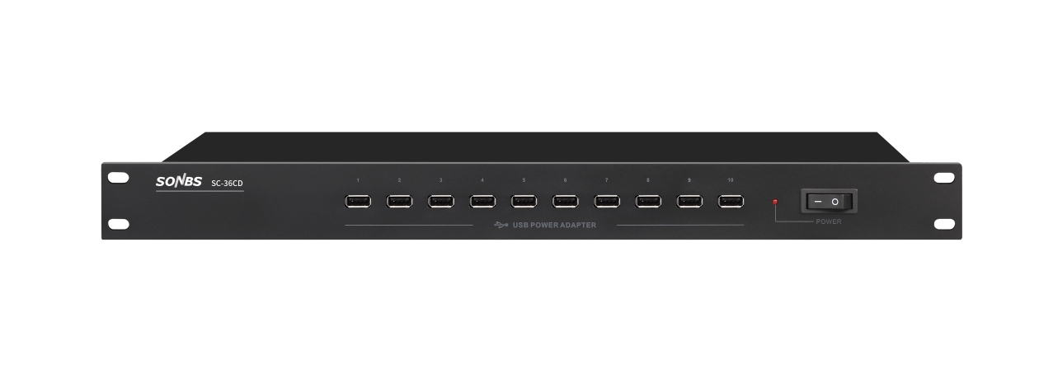
Features：
*The design of charging mode is "constant flow pattern", which is charging for the constant flow when storage battery voltage is lower than preset value. When the storage battery voltage is higher than preset value, charging current will be decreased as the battery voltage increases.
*High working efficiency, protect battery better.
*Perfect protection function: avoid over charge, avoid over flow, greatly reduce the heating from the invalid charging battery.
*Metal paint process case, convenient installation and operation.
*The charging box contains 10 outputs, which can simultaneously provide regular charging, supplementary power, initial charging and equalisation charging for 10 conference microphones with lithium batteries.

Technical parameters:
■ Input voltage: 220V/50Hz
■ Total USB output: 5V/10A
■ Total output power: 50W
■ Single port output (maximum): 5V/10A
■ Single port output (minimum): 5V/1A
■ Single port output power (max): 50W
■ Single port output power (minimum): 5W
■ Dimensions (W*H*D): 480*44*175mm
■ Weight: 2.4Kg

